Marketed by: | Development address: | Contact:
 | Grandview Drive Office Centre  309 Artillery Park DR., Suite 201  FT Mitchell, KY 41017  (859) 657-6700  www.TheBoldCompany.com  ContactUs@TheBoldCompany.com | Mike 859-379-9280  James 859-393-2900  MLS #’s

OFFICE SPACE
FOR SALE or LEASE
LOCATION

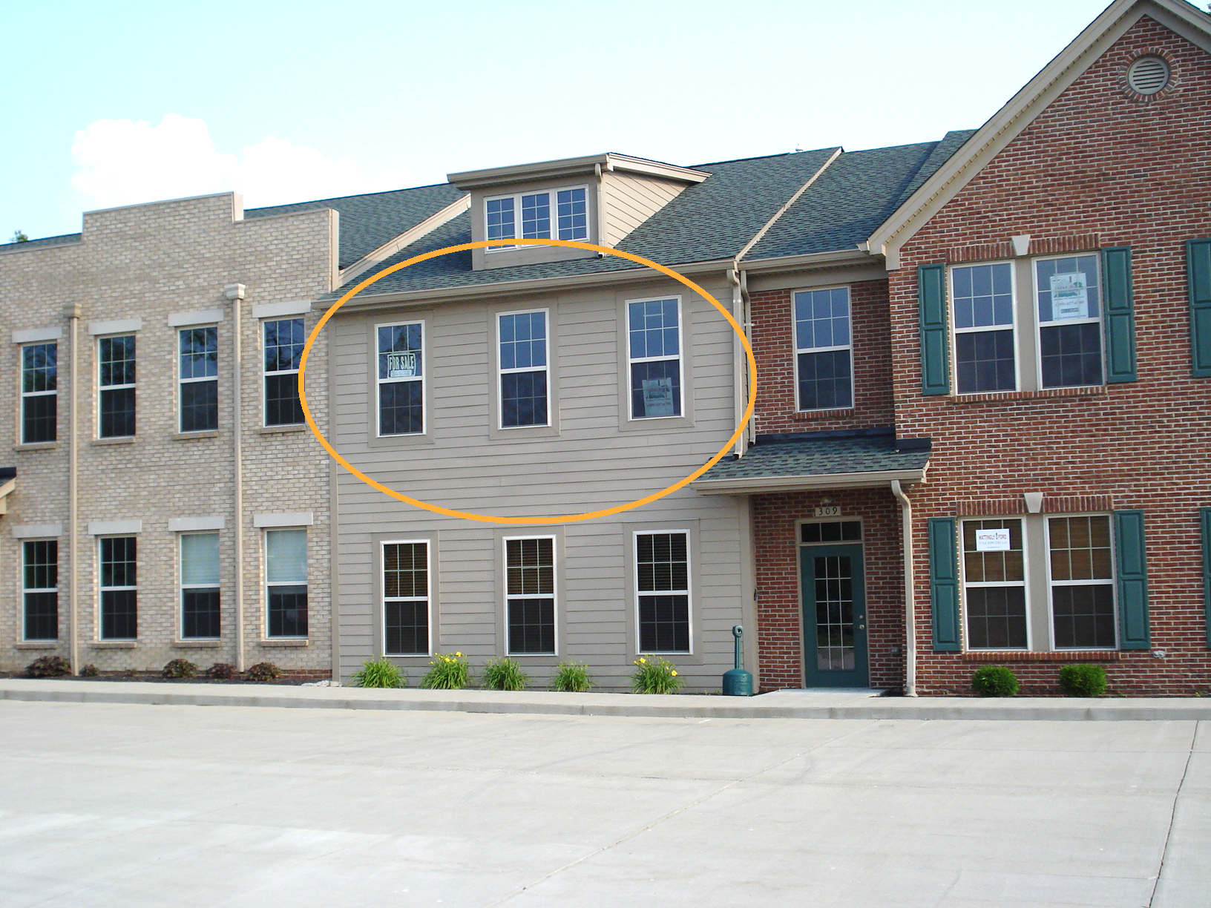

Address | Location | Size | Status | Sale Price | Lease Rate
309-201 | 2nd Floor | 948 SF | AVAILABLE | $140,000 | $1,300/MN

Lease rate includes CAM fees which covers water, sewer, garbage and common area maintenance.

DIRECTIONS: Follow I-71 /I-75 to KY-371 N/Buttermilk Pike in Fort Mitchell. Take exit 186 from I-71 /I-75. Take KY-371 N/Buttermilk Pike for 0.2 mi. Turn right onto Grandview Dr for 0.9 mi. Turn right onto Artillery Park Dr. Destination will be on the right.

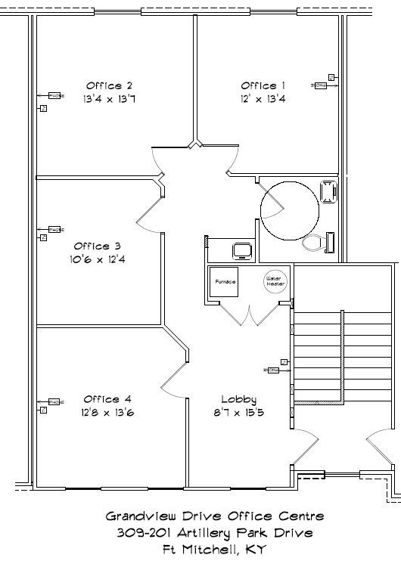
The BOLD Company is a custom Design/Builder of homes and light commercial projects since 1986. Contact us for your building, renovation and tenant finish projects. | 260 Grandview, LLC  The BOLD Company  BOLD Realty  1521Cavalry DR., STE 104.  Florence. KY 41042  Office: (859) 657-6700  e-mail: ContactUs@TheBoldCompany.com  website: www.TheBoldCompany.com | Note: The price of this space is as currently specified. Adjustments to these specifications may be necessary due to different finishes and customer requests or as 260 Grandview, LLC and the BOLD Company may find necessary. Price and features may change without notice. This is not part of a legal contract.
Mike J Kegley, broker and project owner 859-379-9280
James J Kegley, sales associate and project owner 859-393-2900

